1. **LiveLock**:
   1. **Requirement**: To create **LiveLock**.
      1. For this situation to occur, we need infinite loop.
      2. 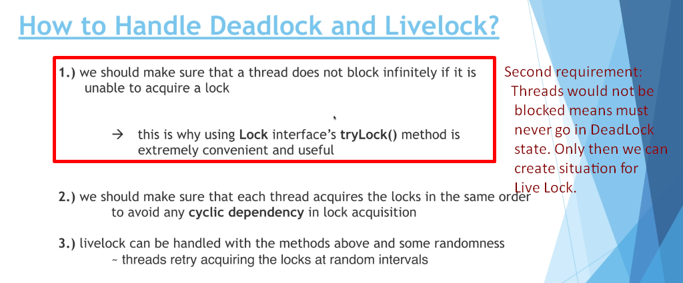
2. 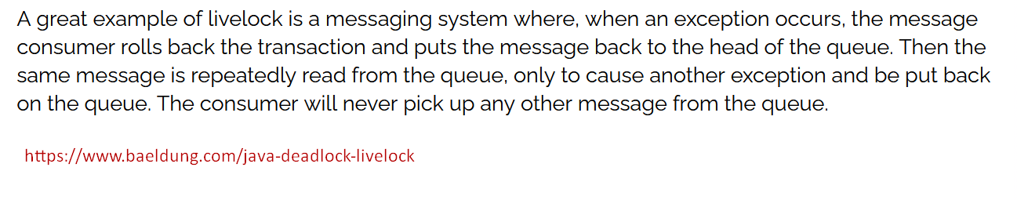
3. This lecture’s code is not clear 🡺 lock.tryLock(50, TimeUnit.MILLISECONDS);